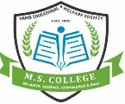
HABIB EDUCATIONAL & WELFARE SOCIETY’S
M. S. COLLEGE
OF ARTS, SCIENCE, COMMERCE & BMS
NAAC ACCREDITED
(Affiliated to The University of Mumbai)

DATE:- 09/04/2025.

NOTICE

All Students are hereby informed that college and its offices will remain closed on 10th April 2025 on occasion of Mahavir Janma Kalyanak.

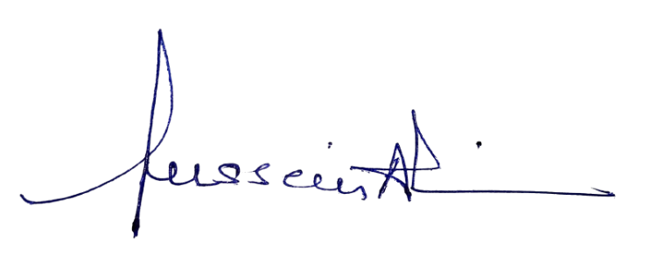
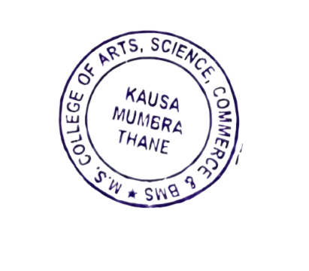
By Order.

HABIB EDUCATIONAL & WELFARE SOCIETY’S
M. S. COLLEGE
OF ARTS, SCIENCE, COMMERCE & BMS
NAAC ACCREDITED
(Affiliated to The University of Mumbai)

DATE:- 12/04/2025.

NOTICE

All Students are hereby informed that college and its offices will remain closed on 14th April 2025 on occasion of Dr. Babasaheb Ambedkar Jayanti.

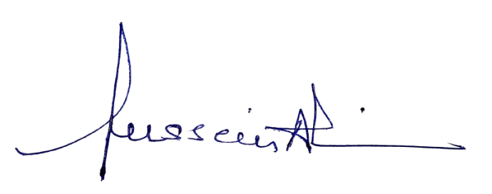
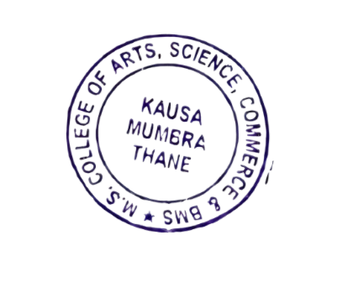
By Order.

HABIB EDUCATIONAL & WELFARE SOCIETY’S
M. S. COLLEGE
OF ARTS, SCIENCE, COMMERCE & BMS
NAAC ACCREDITED
(Affiliated to The University of Mumbai)

DATE:- 17/04/2025.

NOTICE

All Students are hereby informed that college and its offices will remain closed on 18th April 2025 on occasion of Good Friday.

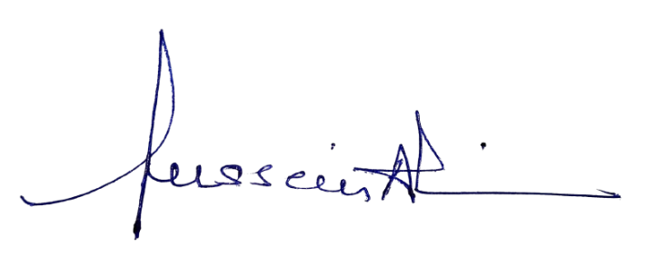
By Order.

HABIB EDUCATIONAL & WELFARE SOCIETY’S
M. S. COLLEGE
OF ARTS, SCIENCE, COMMERCE & BMS
NAAC ACCREDITED
(Affiliated to The University of Mumbai)

DATE:- 10/05/2025.

NOTICE

All Students are hereby informed that college and its offices will remain closed on 12nd May 2025 on occasion of Buddha Purnima.

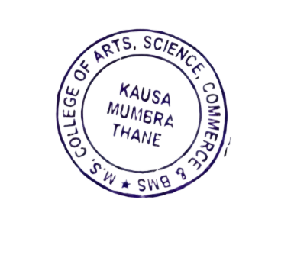
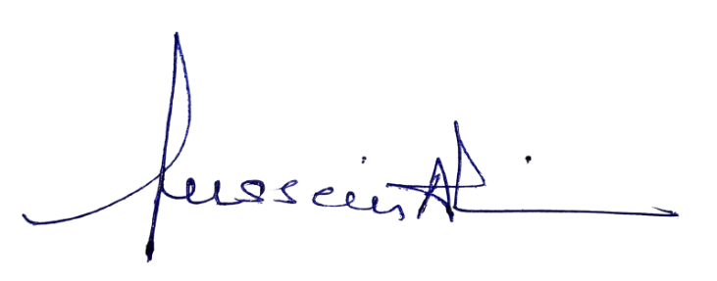
By Order.

HABIB EDUCATIONAL & WELFARE SOCIETY’S
M. S. COLLEGE
OF ARTS, SCIENCE, COMMERCE & BMS
NAAC ACCREDITED
(Affiliated to The University of Mumbai)

DATE:- 13/08/2025.

NOTICE

All Students are hereby informed that college and its offices will remain closed on 16th August 2025 on occasion of Janmashtami.

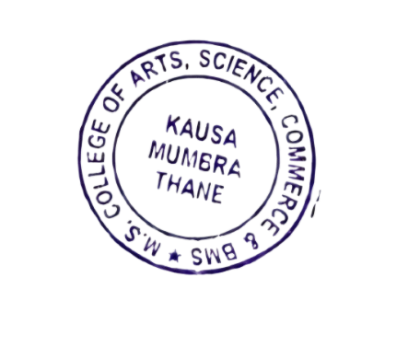
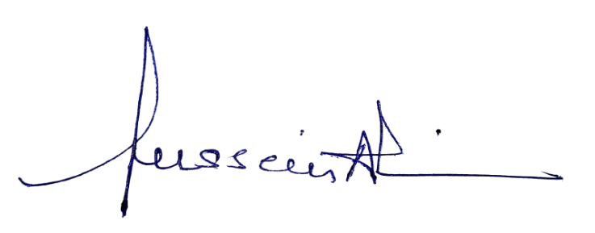
By Order.

HABIB EDUCATIONAL & WELFARE SOCIETY’S
M. S. COLLEGE
OF ARTS, SCIENCE, COMMERCE & BMS
NAAC ACCREDITED
(Affiliated to The University of Mumbai)

DATE:- 25/08/2025.

NOTICE

All Students are hereby informed that college and its offices will remain closed on 27th August 2025 on occasion of Ganesh Chaturthi.

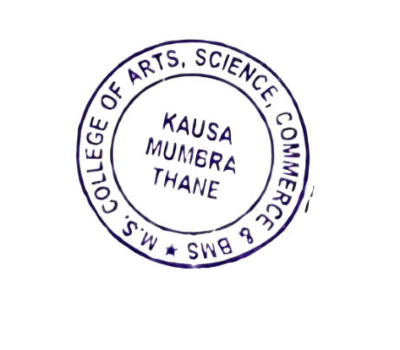
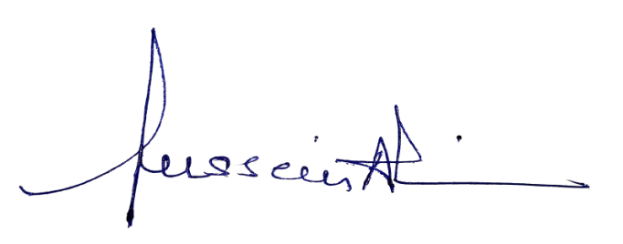
By Order.

HABIB EDUCATIONAL & WELFARE SOCIETY’S
M. S. COLLEGE
OF ARTS, SCIENCE, COMMERCE & BMS
NAAC ACCREDITED
(Affiliated to The University of Mumbai)

DATE:- 01/09/2025.

NOTICE

All Students are hereby informed that college and its offices will remain closed on 02nd September 2025 on occasion of Jesthgauri Visarjan.

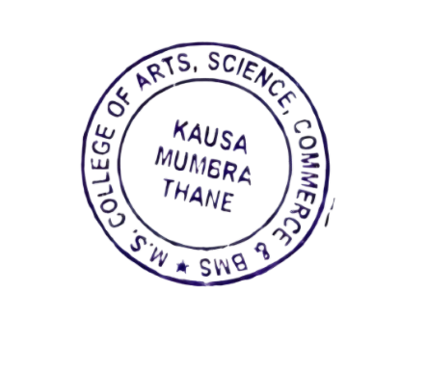
By Order.

HABIB EDUCATIONAL & WELFARE SOCIETY’S
M. S. COLLEGE
OF ARTS, SCIENCE, COMMERCE & BMS
NAAC ACCREDITED
(Affiliated to The University of Mumbai)

DATE:- 03/09/2025.

NOTICE

All Students are hereby informed that college and its offices will remain closed on 05th September 2025 on occasion of Eid-E-Milad.

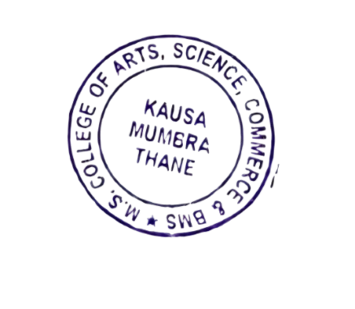
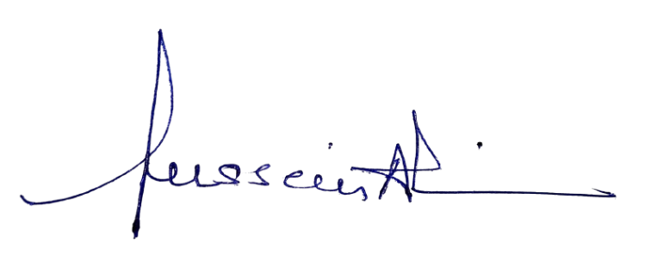
By Order.

HABIB EDUCATIONAL & WELFARE SOCIETY’S
M. S. COLLEGE
OF ARTS, SCIENCE, COMMERCE & BMS
NAAC ACCREDITED
(Affiliated to The University of Mumbai)

DATE:- 03/09/2025.

NOTICE

All Students are hereby informed that college and its offices will remain closed on 06th September 2025 on occasion of Anant Chaturdasi.

By Order.

HABIB EDUCATIONAL & WELFARE SOCIETY’S
M. S. COLLEGE
OF ARTS, SCIENCE, COMMERCE & BMS
NAAC ACCREDITED
(Affiliated to The University of Mumbai)

DATE:- 01/10/2025.

NOTICE

All Students are hereby informed that college and its offices will remain closed on 02nd October 2025 on occasion of Gandhi Jayanti & Dasera.

By Order.

HABIB EDUCATIONAL & WELFARE SOCIETY’S
M. S. COLLEGE
OF ARTS, SCIENCE, COMMERCE & BMS
NAAC ACCREDITED
(Affiliated to The University of Mumbai)

DATE:- 18/10/2025.

NOTICE

All Students are hereby informed that college will remain closed from 20th October 2025 to 05th November 2025 on occasion of Diwali Vacation.
The regular lectures will commence from 06th November 2025.

By Order.

HABIB EDUCATIONAL & WELFARE SOCIETY’S
M. S. COLLEGE
OF ARTS, SCIENCE, COMMERCE & BMS
NAAC ACCREDITED
(Affiliated to The University of Mumbai)

DATE:- 04/11/2025.

NOTICE

All Students are hereby informed that college and its offices will remain closed on 05th November 2025 on occasion of Guru Nanak Jayanti.

By Order.

HABIB EDUCATIONAL & WELFARE SOCIETY’S
M. S. COLLEGE
OF ARTS, SCIENCE, COMMERCE & BMS
NAAC ACCREDITED
(Affiliated to The University of Mumbai)

DATE:- 05/12/2025.

NOTICE

All Students are hereby informed that college and its offices will remain closed on 06th December 2025 on occasion of Dr. Babasaheb Ambedkar Mahaparinivana Day.

By Order.

HABIB EDUCATIONAL & WELFARE SOCIETY’S
M. S. COLLEGE
OF ARTS, SCIENCE, COMMERCE & BMS
NAAC ACCREDITED
(Affiliated to The University of Mumbai)

DATE:- 24/12/2025.

NOTICE

All Students are hereby informed that college and its offices will remain closed on 25th December 2025 on occasion of Christmas.

By Order.

HABIB EDUCATIONAL & WELFARE SOCIETY’S
M. S. COLLEGE
OF ARTS, SCIENCE, COMMERCE & BMS
NAAC ACCREDITED
(Affiliated to The University of Mumbai)

DATE:- 08/01/2026.

NOTICE

All Students are hereby informed that college and its offices will remain closed on 15th January 2026 on occasion of Thane Municipal Corporation General Election 2025-26.

By Order.

HABIB EDUCATIONAL & WELFARE SOCIETY’S
M. S. COLLEGE
OF ARTS, SCIENCE, COMMERCE & BMS
NAAC ACCREDITED
(Affiliated to The University of Mumbai)

DATE:- 23/01/2026.

NOTICE
All students are hereby informed that our College is organizing a Blood Donation Drive.
Details are as follows:
- Venue: Shakeela Khan Auditorium
- Date: 24th January 2026
- Time: 10:00 a.m. to 03:00 p.m.
Students who are eligible and willing to donate blood are encouraged to participate in this noble cause.

By Order.

